There are 4 modual in node

1.fs
2.http
3.https
4.os
5.path

this modual are all in node we have to take
creating node server

when we create the server we have to create object that object should be const
because we should not change

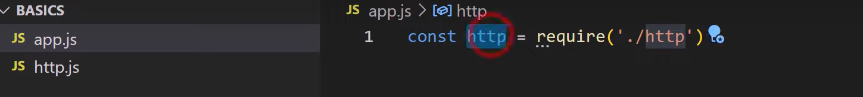
this require function help to get the file not only modual it will get all like your file my file like government .

./http it will check our folder there is http file here or not //in our house

/http it will check whole node js // in whole world

now to got the modual there are method in http modual .

The important method is createServer() its help to create the server in this moethod we have to give method

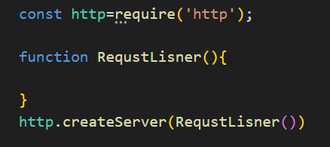
When the appliction will face the request the create server called createServer() will call the RequestLisner() createserver() will give 2 parameters to Requestlistner that parameters are request and response .
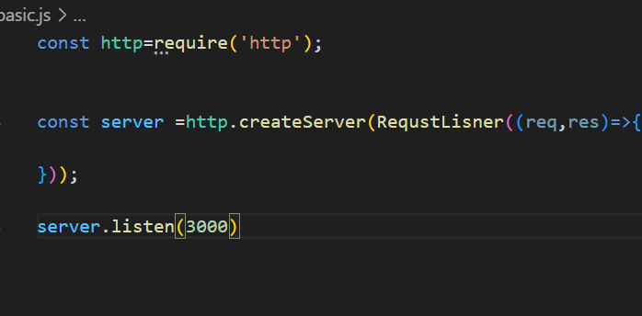
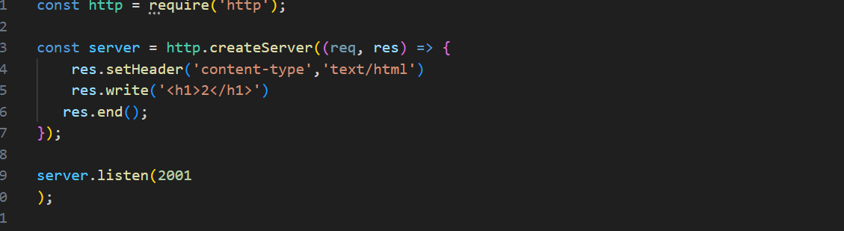
Event loop means programe will run always
We use arrow function
in Listen we give the port number
if request come we send the response in response we send the h1 tag
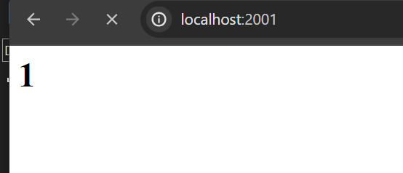
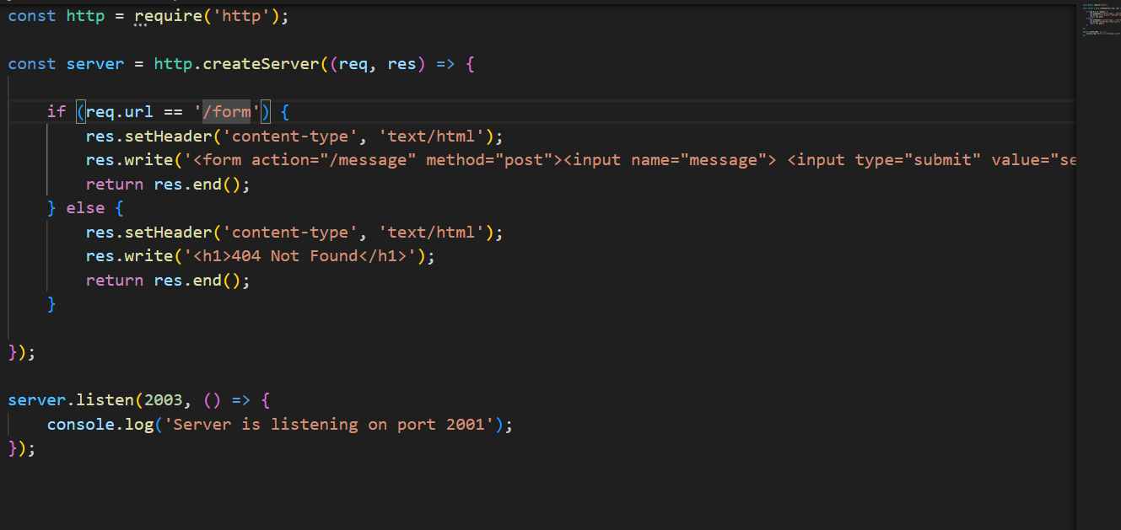
here I wrote program if if url is /form show form else show 404 h1 tag
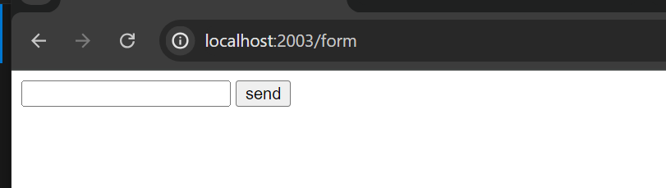
here is showing the form because the url is form
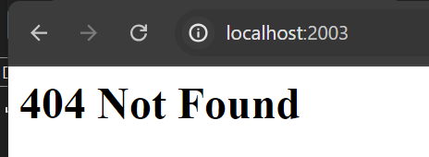
else I am showing 404

